TITLE OF PAPER

(Times New Roman, 14 pt., bold, center, single space, all caps)
Author 1 Name SURNAME*
Author 2 Name SURNAME*
Abstract: Your abstract should contain at least your research topic, research questions, participants, methods, results, data analysis, and conclusions. You may also include possible implications of your research and future work you see connected with your findings. Your abstract should be between 150 and 250 words. The abstract shall be written with times new roman, font size 11, italic, single spacing, justified. It shall include 150-250 words.
Keywords: select 5-8 key terms (words or phrases) that reveal the essence of the paper. List these terms in the decreasing order of their significance.
JEL Code: Please see: https://www.aeaweb.org/econlit/jelCodes.php?view=jel

Introduction
Its meaning is to establish the context of the paper. In the introduction you should state the problem or objective of your research paper (why did you study? Why it is worth studying? Does the proposed study have practical significance?); formulate the research question(s) and briefly discuss the structure of your paper, i.e. what follows in the section two, three etc. Anytime it is possible, describe the results revealed (proved) by the study.
Use Times New Roman font, size 12; line spacing - 1,15 cm. First line – 1cm; Alignement – Justified.
In this section do critical review of the quant articles/papers that are relevant to your research topic/question. This review should include the research question asked by the authors; theories used; research hypothesis stated; significance of the study; data, sources, variables etc.; statistical tools used in the analysis; findings and implications of the papers of your study – theory, data and statistical techniques.
Use the author–date citation system to cite references in the text in APA Style. In this system, each work used in a paper has two parts: an in-text citation and a corresponding reference list entry. All citation must correspond to a reference in the main reference list.
In-text citations may be parenthetical or narrative.
- In parenthetical citations, use an ampersand (&) between names for a work with two authors or before the last author when all names must be included to avoid ambiguity (ex. Mitchell, Smith, & Thomson, 2017). For a work with three or more authors, include the name of only the first author plus “et al.” in every citation (even the first citation) (ex. Martin et al., 2020);
- In narrative citations, always spell out the word “and.” (Ex: Mitchell, Smith, and Thomson (2017) state…).
Examples of basic in-text citation styles are represented in the table below.
Table 1. Examples of different citation styles:
Author type | Parenthetical citation | Narrative citation
One author | (Luna, 2020) | Luna (2020) argues that....
Two authors | (Salas & D’Agostino, 2020) | Salas and D’Agostino (2020) claim....
Three or more authors | (Martin et al., 2020) | Martin et al. (2020) state....
Group author with abbreviation  First citation ª  Subsequent citations | (National Institute of Mental Health [NIMH], 2020)  (NIMH, 2020) | National Institute of Mental Health (NIMH, 2020)  NIMH (2020)
Group author without abbreviation | (Stanford University, 2020) | Stanford University (2020)
Source: APA, Author–Date Citation System. https://apastyle.apa.org/style-grammar-guidelines/citations/ basic-principles/author-date

For more details about the requiremnt for in-text citations ( i.e. number of authors to include in in-text citations; exceptions to the basic in-text citation styles; dates in a citation, repeating a citation, etc), please see - https://apastyle.apa.org/style-grammar-guidelines/citations/basic-principles/author-date
QUOTATIONS: A direct quotation reproduces words verbatim from another work or from your own previously published work. Use direct quotations rather than paraphrasing:
- when reproducing an exact definition,
- when an author has said something memorably or succinctly, or
- when you want to respond to exact wording (e.g., something someone said).
For quotations of fewer than 40 words, add quotation marks around the words and incorporate the quote into your own text—there is no additional formatting needed. (For ex: Effective teams can be difficult to describe because “high performance along one domain does not translate to high performance along another” (Ervin et al., 2018, p. 470).)
For quotations of 40 or more word (i.e. block quotations) do not use quotation marks and should be inserted on a new line and indent the whole block 1,27 cm from the left margin.

Block quotation with parenthetical citation:
Researchers have studied how people talk to themselves:
Inner speech is a paradoxical phenomenon. It is an experience that is central to many people’s everyday lives, and yet it presents considerable challenges to any effort to study it scientifically. Nevertheless, a wide range of methodologies and approaches have combined to shed light on the subjective experience of inner speech and its cognitive and neural underpinnings. (Alderson-Day & Fernyhough, 2015, p. 957)

Block quotation with narrative citation:
Flores et al. (2018) described how they addressed potential researcher bias when working with an intersectional community of transgender people of color:
Everyone on the research team belonged to a stigmatized group but also held privileged identities. Throughout the research process, we attended to the ways in which our privileged and oppressed identities may have influenced the research process, findings, and presentation of results. (p. 311)
For examples and more details about how to edit quotations, please see - https://apastyle.apa.org/ stylegrammar-guidelines/citations/quotations

3. Data and Methodology
Describe what indicators you wil be used to measure the variables of your model, what is the source of your data and what methods of research you will be using in your paper. Use Times New Roman font, size 12; line spacing - 1,15 cm; Alignement – Justified.

4. The Model and Findings
In this section describe the model you are going to use and the hypotheses that you are formally testing. Ehat is your dependent and independent variables? Do the descriptive analysis of your dependent and independent variables.
For Bullets and numbering use simple lines
- Hhhhhhhhhhhhhhhh;
- Hhhhhhhhhhhhhhhhhhhhhh;
or arab numbers
- Hhhhhhhhhhhhhhhh;
- Hhhhhhhhhhhhhhhhhhhhhh;
TNR 12, left identation and hanging, 1 cm.
Tables:
Tables should be numbered sequentially (Table 1, Table 2, etc.), should have a title and the width of the page. A source should be added below the table.

Table 1. Title of the table (Times New Roman, 12 pt., bold, left)
Country/year | 2002 | 2007 | 2012 | 2017 | Population for 2018, million
Bulgaria | -85500 | -83742 | -24472 | -24001 | 7024216
Czech Republic | 47402 | 250889 | 59997 | 59997 | 10625695
Estonia | -18406 | -15151 | -10516 | -4999 | 1320884
Hungary | 61589 | 25150 | 29999 | 29999 | 9768785
Source: World Bank http://www.worldbank.org (Times New Roman, 10 pt., italic, left)
Data in the table should be formatted with Times New Roman font, 10 pt. A table should be centered against the text in the paragraph/subparagraph.
Figures:
Graphs, charts and pictures should be inserted with the option Wrap Text – In Line with Text. Titles of that objects are written below them preceded by the number of the figure (Figure 1, Figure 2, etc.). A source should be added below the title of the figure.
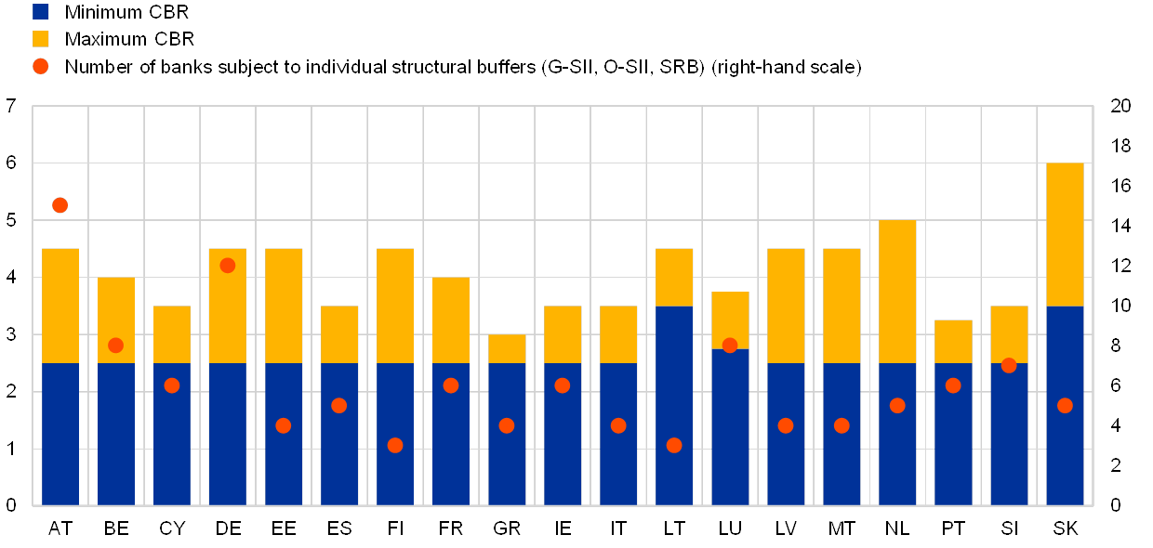
Figure 1. Title of the figure (Times New Roman, 12 pt., bold, left)
Source: www.nsi.bg (Times New Roman, 10 pt., italic, left)
Diagrams have to be clearly executed in order to provide visible black and white copies.
Equations and formulas:
Number all equations and formulas placing their numbers in parentheses, on their right side.
$a^{2}+b^{2}=c^{2}$ (1)

Abbreviations and acronyms:
Explain abbreviations and acronyms when they appear first in the text, even if they have been defined in the abstract. Example: Eastern European Journal of Regional Studies (EEJRS)

Conclusions
The concluding section discusses the implications of the analysis, shortcomings in the research, and avenues for the future research.

References
The complete references list is placed at the end of the paper, listed in alphabetical order, by family name. It should b single spaced, TNR 12, hanging – 1cm.
For examples on how to write references - https://apastyle.apa.org/style-grammar-guidelines/references/examples
Some examples of how to write referneces:
- Journal article References
Grady, J. S., Her, M., Moreno, G., Perez, C., & Yelinek, J. (2019). Emotions in storybooks: A comparison of storybooks that represent ethnic and racial groups in the United States. Psychology of Popular Media Culture, 8(3), 207-217. https://doi.org/10.1037/ppm0000185
- Books/Ebooks References
Jackson, L. M. (2019). The psychology of prejudice: From attitudes to social action (2nd ed.). American Psychological Association. https://doi.org/10.1037/0000168-000
Svendsen, S., & Løber, L. (2020). The big picture/Academic writing: The one-hour guide (3rd digital ed.). Hans Reitzel Forlag. https://thebigpicture-academicwriting.digi.hansreitzel.dk/
Torino, G. C., Rivera, D. P., Capodilupo, C. M., Nadal, K. L., & Sue, D. W. (Eds.). (2019). Microaggression theory: Influence and implications. John Wiley & Sons. https://doi.org/10.1002/9781119466642
Chapter in an Edited Book/Ebook References
Dillard, J. P. (2020). Currents in the study of persuasion. In M. B. Oliver, A. A. Raney, & J. Bryant (Eds.), Media effects: Advances in theory and research (4th ed., pp. 115–129). Routledge.
Thestrup, K. (2010). To transform, to communicate, to play—The experimenting community in action. In E. Hygum & P. M. Pedersen (Eds.), Early childhood education: Values and practices in Denmark. Hans Reitzels Forlag. https://earlychildhoodeducation.digi.hansreitzel.dk/?id=192
Dictionary Entry References
American Psychological Association. (n.d.). Just-world hypothesis. In APA dictionary of psychology. Retrieved January 18, 2020, from https://dictionary.apa.org/just-world-hypothesis
Merriam-Webster. (2003). Litmus test. In Merriam-Webster’s collegiate dictionary (11th ed., p. 727).
Report by a Government Agency References
National Cancer Institute. (2019). Taking time: Support for people with cancer (NIH Publication No. 18-2059). U.S. Department of Health and Human Services, National Institutes of Health. https://www.cancer.gov/publications/patienteducation/takingtime.pdf
- Report with Individual Authors References
Baral, P., Larsen, M., & Archer, M. (2019). Does money grow on trees? Restoration financing in Southeast Asia. Atlantic Council. https://www.atlanticcouncil.org/in-depth-researchreports/report/does-money-grow-on-trees-restoring-financing-insoutheast-asia/
Stuster, J., Adolf, J., Byrne, V., & Greene, M. (2018). Human exploration of Mars: Preliminary lists of crew tasks (Report No. NASA/CR2018-220043). National Aeronautics and Space Administration. https://ntrs.nasa.gov/archive/nasa/casi.ntrs.nasa.g ov/20190001401.pdf
- White Paper References
Department for Business Innovation & Skills. (2016). Success as a knowledge economy: Teaching excellent, social mobility and student choice [White paper]. Crown. https://www.gov.uk/government/uploads/system/uploads/ attachment_data/file/523396/bis-16-265-success-as-a-knowledgeeconomy.pdf
- Conference proceedings published as a whole book
Kushilevitz, E., & Malkin, T. (Eds.). (2016). Lecture notes in computer science: Vol. 9562. Theory of cryptography. Springer. https://doi.org/10.1007/978-3-662-49096-9
- Conference proceedings published as a book chapter
Bedenel, A.-L., Jourdan, L., & Biernacki, C. (2019). Probability estimation by an adapted genetic algorithm in web insurance. In R. Battiti, M. Brunato, I. Kotsireas, & P. Pardalos (Eds.), Lecture notes in computer science: Vol. 11353. Learning and intelligent optimization (pp. 225–240). Springer. https://doi.org/10.1007/978- 3-030-05348-2_21
- Conference Presentation References
Evans, A. C., Jr., Garbarino, J., Bocanegra, E., Kinscherff, R. T., & Márquez-Greene, N. (2019, August 8–11). Gun violence: An event on the power of community [Conference presentation]. APA 2019 Convention, Chicago, IL, United States. https://convention.apa.org/2019-video

* Name Surname, Scientific title and affiliation, Email, ORCID:
* Name Surname, Scientific title and affiliation, Email, ORCID: (with Times New Roman, font size 10, italic.)

